Linux Commands end-to-end Cheat sheet
Command: whoami
Description: Displays the current user account.
Example: Running whoami in the terminal will show your username, like john_doe.
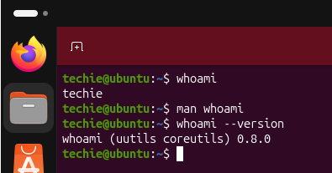
Command: ls
Description: Lists files and directories in the current directory.
Example: ls will display files and folders in your current directory, and ls -l provides detailed information.
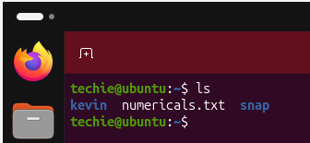
Command: ip a
Description: Lists your IP address and network interfaces.
Example: ip a show all network interfaces and their IP addresses
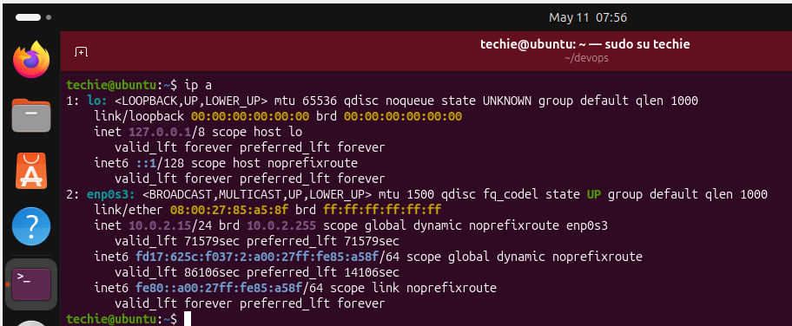
Command: cat
Description: Reads the contents of text files.
Example: cat myfile.txt will display the content of myfile.txt.
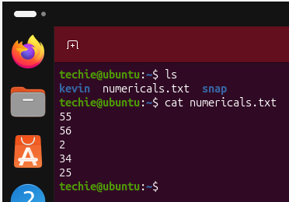
Command: passwd
Description: Used to change the password of the user account.
Example: Typing passwd and following the prompts will allow you to change your password.
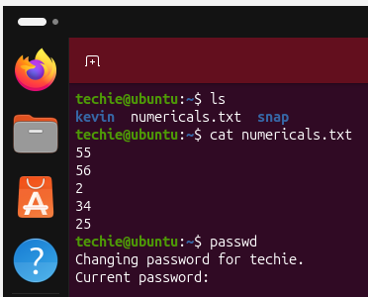
Command: touch
Description: Creates empty files, mainly useful to test write ability.
Example: touch newfile.txt creates an empty file named newfile.txt.
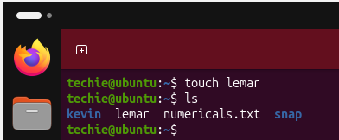
Command: pwd
Description: Stands for Print Working Directory; shows which directory you are in.
Example: Running pwd might return /home/john_doe.
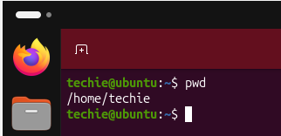
Command: man
Description: Accesses the system documentation for commands.
Example: man ls will show the manual for the ls command.
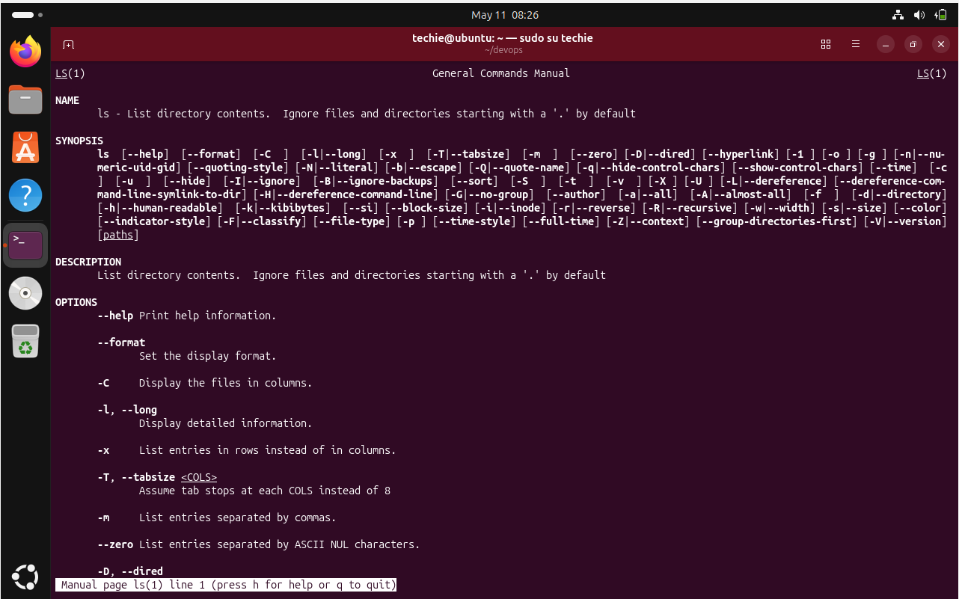
Command: apropos
Description: Searches commands related to a specific task based on description (equivalent to man -k).
Example: apropos "list files" might return commands related to listing files.
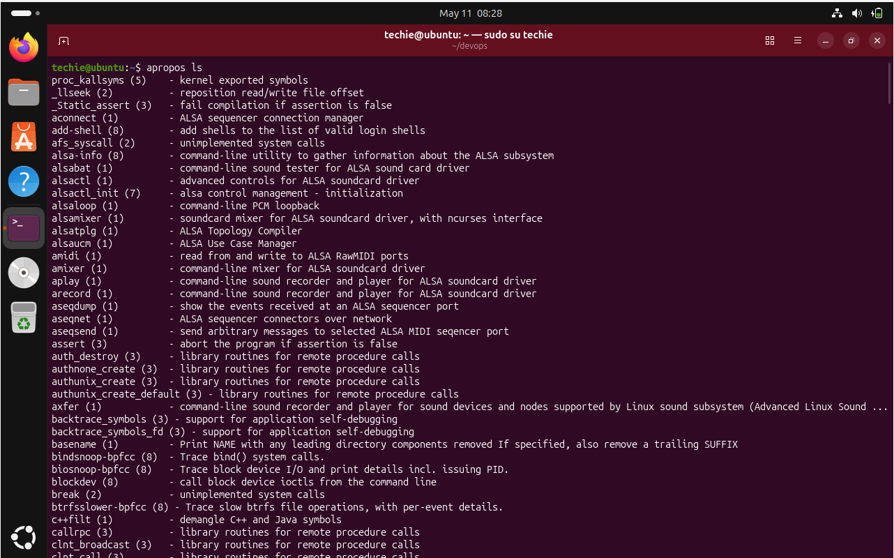
Command: pinfo
Description: Provides additional information, similar to man.
Example: pinfo ls gives detailed information about the ls command.
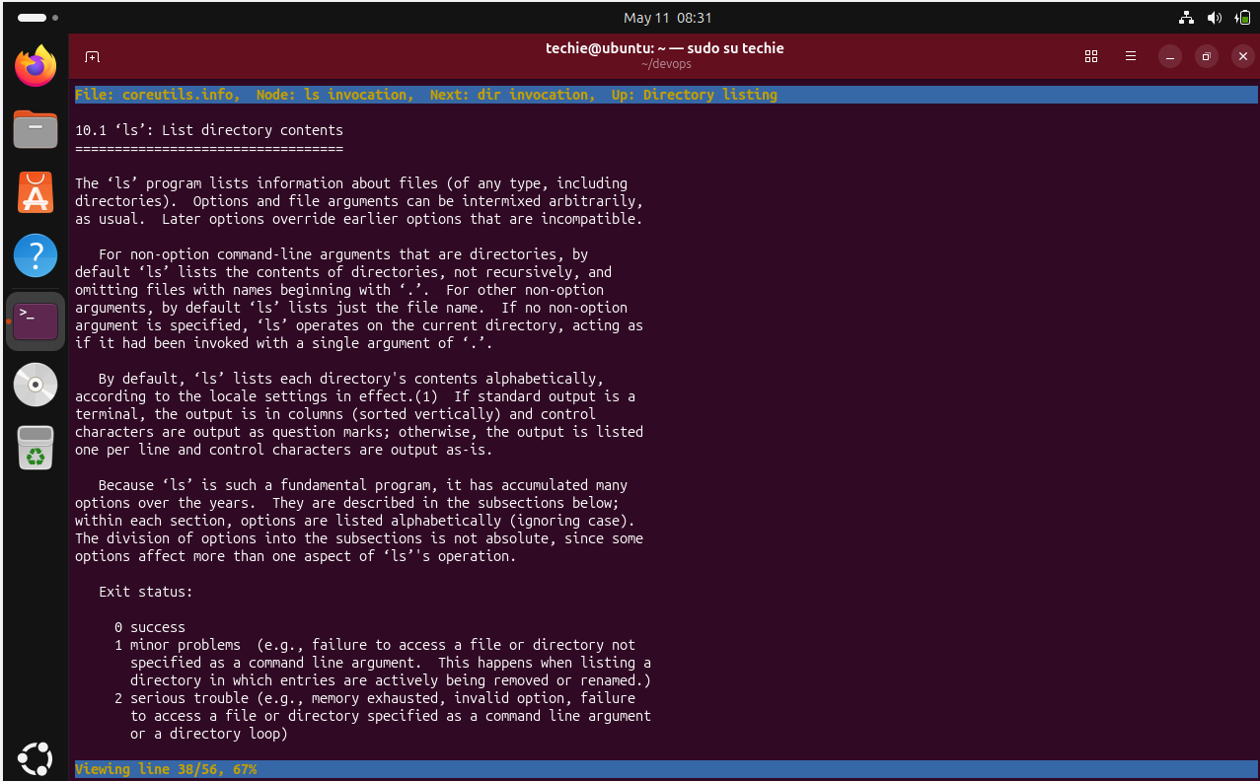
Command: tldr
Description: Shows command line examples, a simplified version of man.
Example: tldr passwd provides quick examples of how to use the passwd
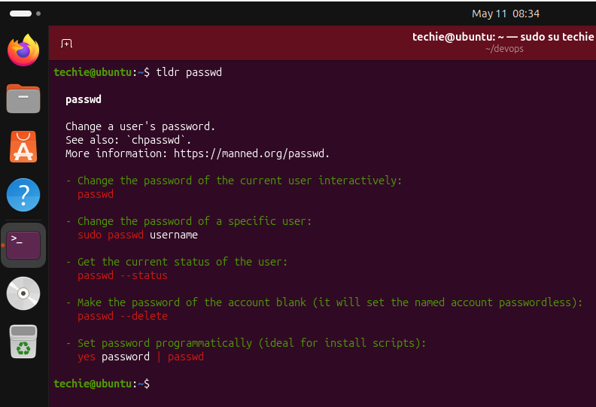

Essential File Management Tools Commands
Command: ls
Example: ls /home/user/Documents
Description: Lists files and directories within a specified path. This command is used to view the contents of directories.

Command: cp
Example: cp source.txt destination.txt
Description: Copies files from one location to another. This command is used to make duplicates of files.
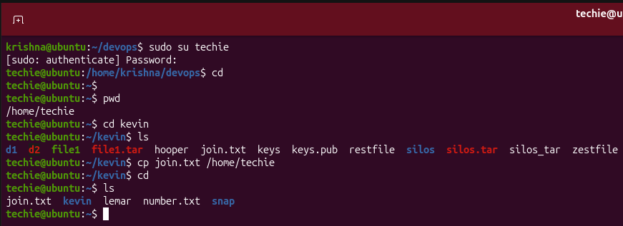
Command: mkdir
Example: mkdir new_directory
Description: Creates a new directory. This command is used when you need to make a new folder.
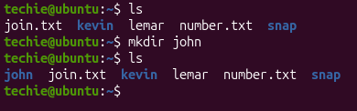
Command: rmdir
Example: rmdir empty_directory
Description: Removes a directory, but only if it's empty. This command is used for deleting empty folders.
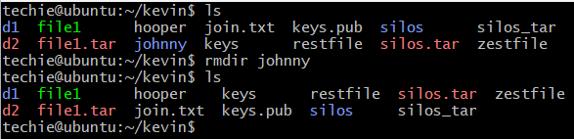
Command: mv
Example: mv oldname.txt newname.txt
Description: Moves or renames files and directories. This command can change the location or the name of a file
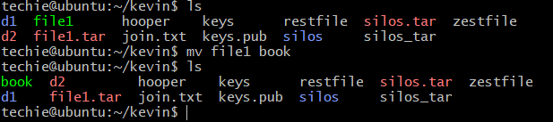
Command: rm
Example: rm filename.txt
Description: Removes files or directories. This command deletes files or directories.
Note: When combined with options -r (recursive) and -f (force), as in rm -rf directory_name, it becomes a powerful command that can delete directories and their contents without asking for confirmation.
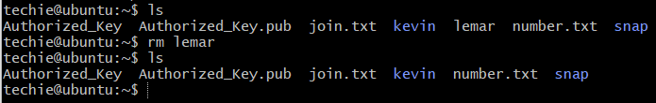

Advanced File Management Tools Commands

ln: Used for creating hard and symbolic links.
Example: ln -s source_file symbolic_linkcreates a symbolic link to source_file.
Description: Links a file or directory to another location.
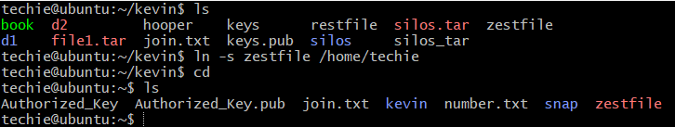
find: A utility to find files based on various properties.
Example: find /home -name "*.txt"searches for text files in the /home directory.
Description: Searches for files and directories in a given path.
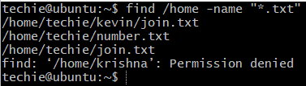
locate: Used for quickly searching the database of system's contents.
Example: locate filename finds the location of filename.
Description: Fast file searching, requires running updatedb for an updated database.

which: Finds the location of executables in the PATH.
Example: which python shows the path of the Python executable.
Description: Useful for finding executable files in system's PATH.
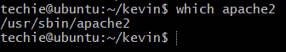
tar: Archives multiple files into a single file.
Example: tar -cvf archive.tar /foldercreates an archive of a folder.
Description: Combines multiple files into a tarball.
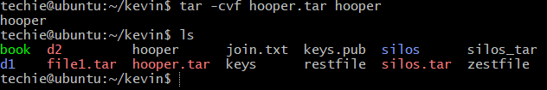
gzip: Compresses files.
Example: gzip file.txt compresses file.txt.
Description: Reduces the size of files using compression.
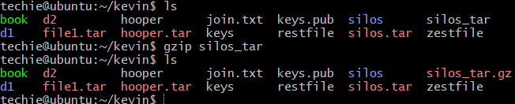
bzip2: A file compression utility.
Example: bzip2 file.txt compresses file.txt.
Description: Offers better compression ratios than gzip at the cost of speed.
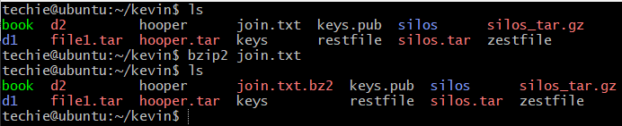
xz: High compression utility.
Example: xz file.txt compresses file.txt.
Description: Provides the best compression ratio.
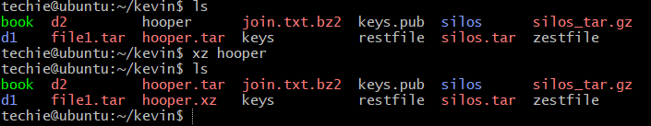
zip: Used for packaging and compressing (archiving) files.
Example: zip archive.zip file1 file2 creates an archive with file1 and file2.
Description: Commonly used for creating .zip files.
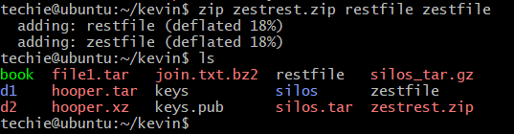
file: Determines the type of a file.
Example: file image.jpg displays the type of image.jpg.
Description: Useful for identifying file formats.
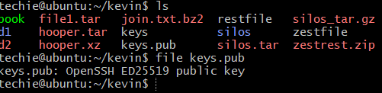
mount: Attaches a filesystem to a specified directory.
Example: mount /dev/sdb1 /mnt mounts the device sdb1 to /mnt.
Description: Used to access filesystems on different storage devices.

df: Displays disk space usage of all mounted filesystems.
Example: df -h shows disk space in human-readable format.
Description: Useful for monitoring disk space usage.
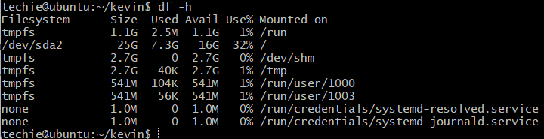
findmnt: Lists all mounted filesystems.
Example: findmnt -t ext4 lists all ext4 type mounts.
Description: Displays a tree-like structure of mounts.

lsblk: Lists information about block devices.
Example: lsblk lists all block devices.
Description: Useful for identifying storage devices and their partitions.

Working with Text Files Commands
more
Description: A pager to view the contents of text files, one screen at a time.
Example: more filename.txt - Views the content of filename.txt.
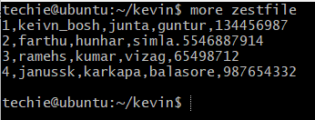
less
Description: Similar to more, but provides more control over viewing text files.
Example: less filename.txt - Opens filename.txt for viewing with navigation options.
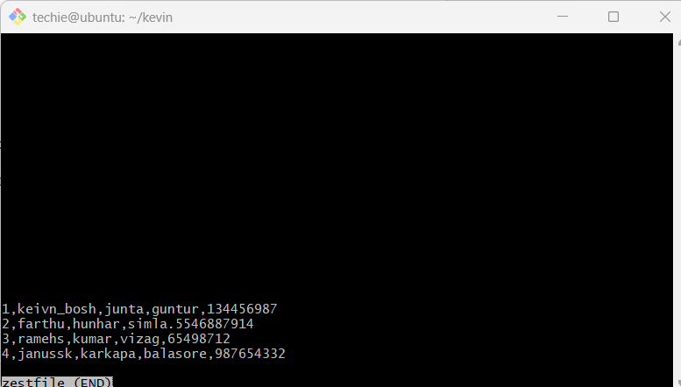

head
Description: Displays the first few lines of a text file.
Example: head filename.txt - Shows the top lines of filename.txt.
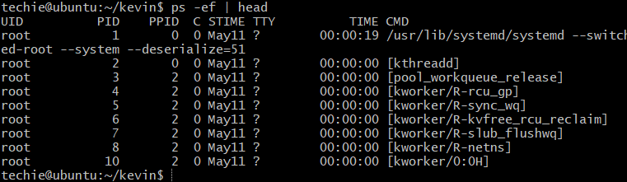
tail
Description: Displays the last few lines of a text file.
Example: tail filename.txt - Shows the last lines of filename.txt.
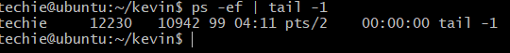
cat
Description: Concatenates and displays the entire content of text files.
Example: cat filename.txt - Displays the full content of filename.txt.
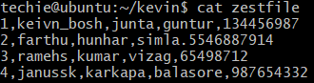
cat -A
Description: Similar to cat, but also displays special characters.
Example: cat -A filename.txt - Shows the content of filename.txt, including special characters.
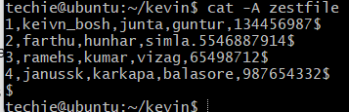
tac
Description: Prints the contents of a text file in reverse order.
Example: tac filename.txt - Displays filename.txt content backwards.
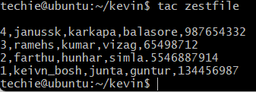
grep
Description: Searches for text in files or command output.
Example: grep 'pattern' filename.txt- Searches for 'pattern' in filename.txt.
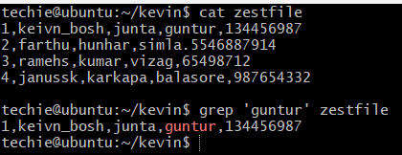

Reading Log Files Commands

Command: journalctl
Description: This command is used to check the contents of the systemd journal, which is a centralized logging system for Linux.
Example: journalctl -u nginx.service
This example shows how to view logs for the Nginx service using journalctl.
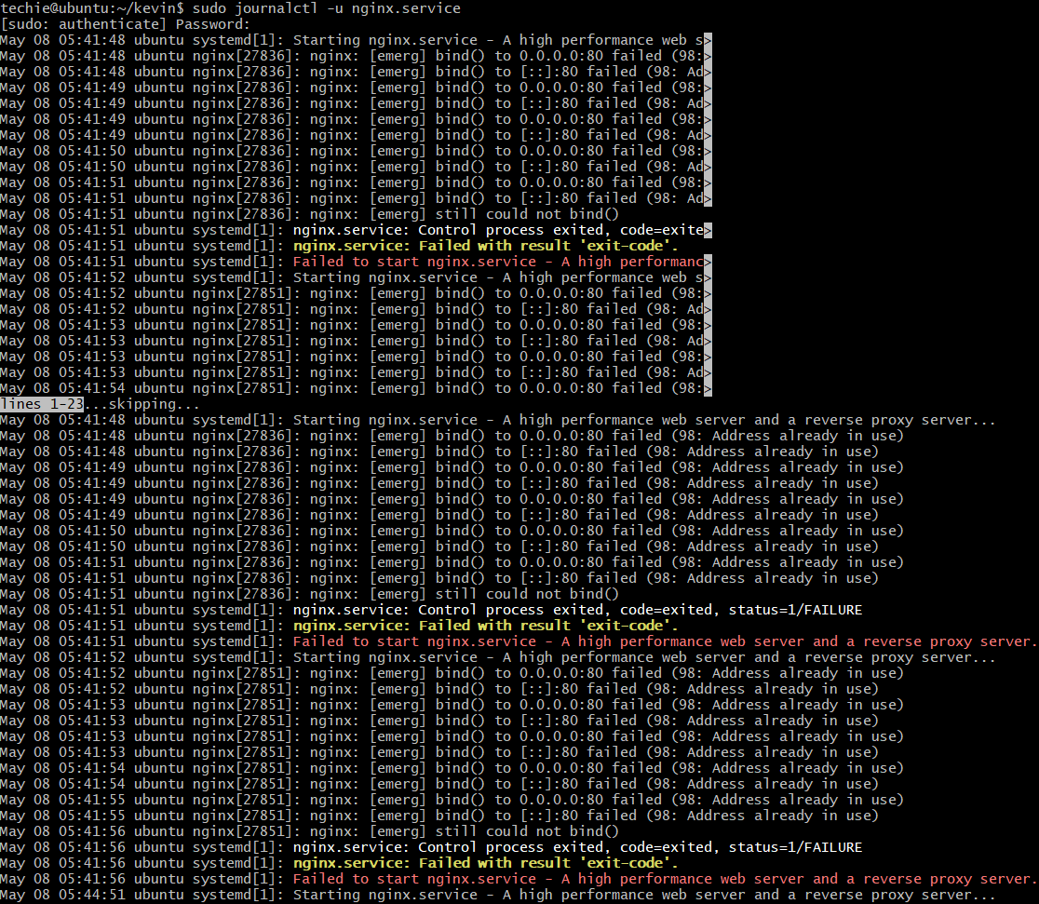
Command: tail
Description: The tail command is used to view the contents of log files, typically the last few lines.
Example: tail -n 100 /var/log/syslog
This example displays the last 100 lines of the syslog file.
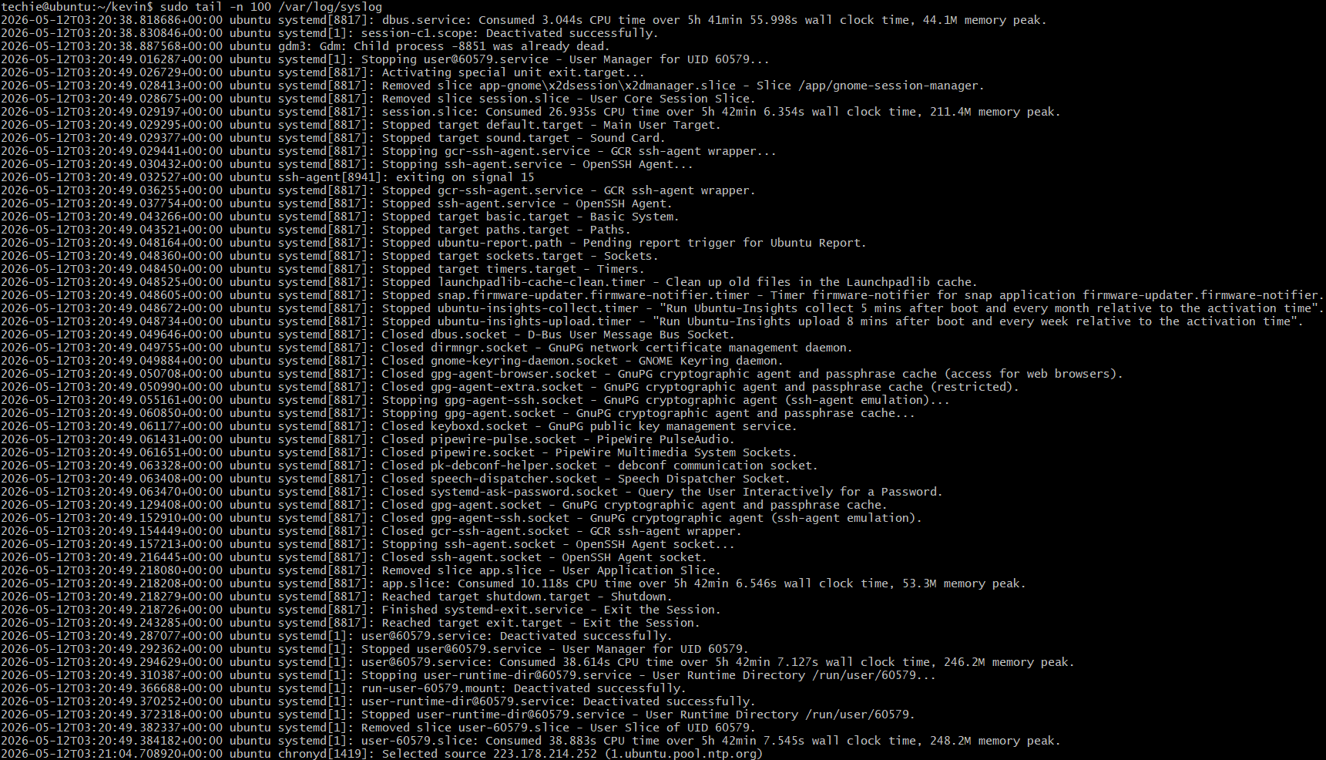

Command: less
Description: Similar to tail, less is used for viewing log files but allows for more controlled navigation through the file.
Example: less /var/log/apache2/access.log
This opens the Apache access log file in a scrollable interface for in-depth examination.

Command: logger
Description: The logger command is a convenient tool for writing messages to the system log.
Example: logger "System backup completed"
This example sends a custom message, "System backup completed," to the system log.

Advanced Text File Processing Commands

grep:
Command: "grep"
Example: "grep 'pattern' file.txt"
Description: Filters text in files by searching for specific patterns.

awk:
Command: "awk"
Example: "awk '/pattern/ {print}' file.txt"
Description: Filters and processes text, with additional features for text manipulation.

sed:
Command: "sed"
Example: "sed 's/old/new/' file.txt"
Description: A stream editor used for modifying text files directly from the command line.

tr:
Command: "tr"
Example: "tr '[:lower:]' '[:upper:]' < file.txt"
Description: Translates or deletes characters from input text.

cut:
Command: "cut"
Example: "cut -d':' -f1 file.txt"
Description: Extracts sections from each line of files, such as columns from a table.

sort:
Command: "sort"
Example: "sort file.txt"
Description: Sorts text files in alphabetical or numerical order, as specified.

